24.11: a) 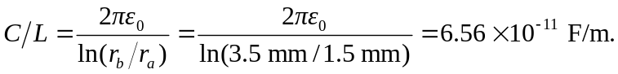
b) The charge on each conductor is equal but opposite. Since the inner conductor is at a higher potential it is positively charged, and the magnitude is:
